Plan your destination Liepaja!

2nd International Week at Liepaja University: Exchanging Experiences

PROGRAMME: 14-17 MAY 2019

14.05.2019 | 15.05.2019 | 16.05.2019 | 17.05.2019
10:00 Welcome by Liepaja University authorities: Rector Dace Markus and Vice Rector for Studies Māra Zeltiņa  Lielā street 14  10:15-12:00 Workshop No1 – exchanging experiences on Erasmus+ KA1 projects  Lielā street 14  Guided city tour  Networking Event | 11:00-12:30 Workshop No2 – exchanging experiences on Erasmus+ KA2 projects  Lielā street 14  Reception at Liepaja City Council  Excursion to former Military part of the city – Karosta | 11:00-12:30 Workshop No3 – exchanging experiences on challenges in a work with international students  Lielā street 14  12:30-13:00 Closing remarks of 3 days workshop programme  Cultural Exchanges: Let’s discover Latvian culture | 10:00 Excursion to different departments of Liepaja University  Meeting at the room 218 - Lielā street 14  11:00 Job shadowing in different areas at Liepaja University (by individual programme)

If you are interested to participate in the international week, please contact Erika Lauberga via erika.lauberga@liepu.lv !
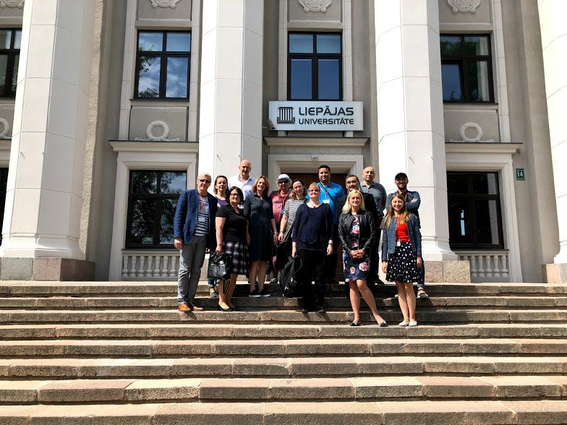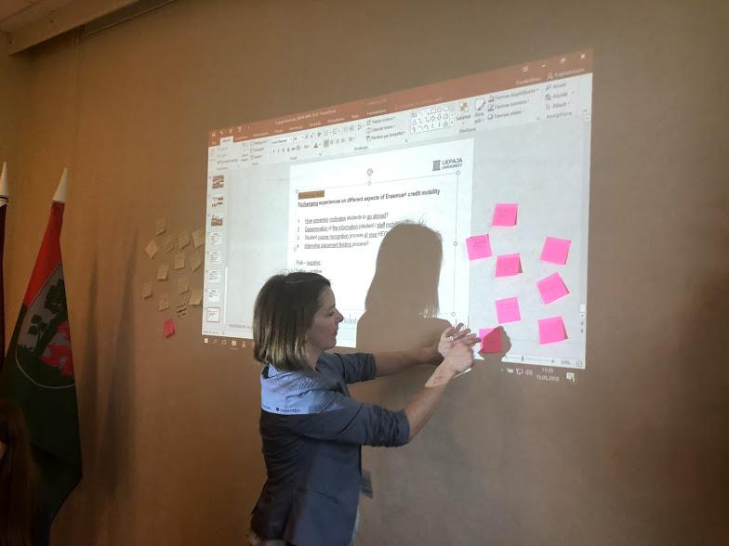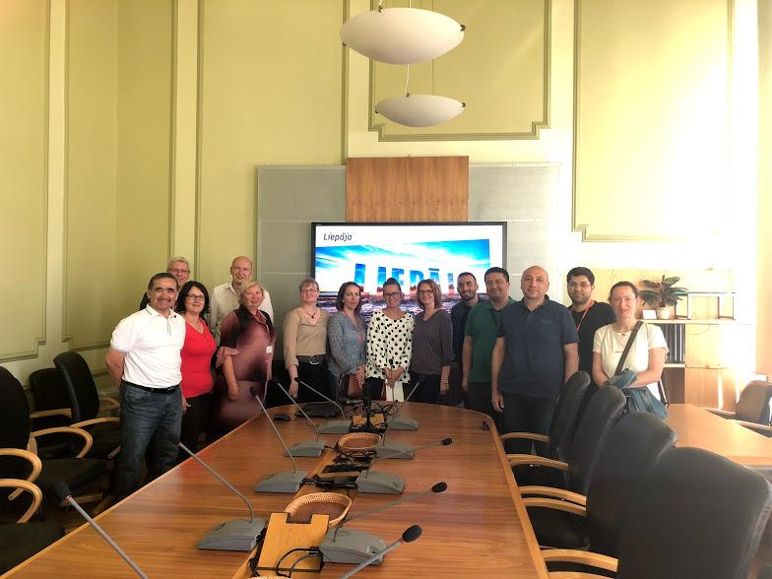
- Good impressions of Liepaja University, this week proved the words said by Rector, that the university is a small, but elegant university! You are like a family, I am jealous for it in a good way. It was a good combination of formal workshops and cultural events. I hope we will have a great cooperation in the future! - Anželika Slimanavičiene, Vilniaus kolegija/ University of Applied Sciences
- New experiences / information about Erasmus+ programme; impressions about Latvia; pleasant stay in Liepaja; meeting with nice colleagues. Well organized event in everything (timetable / hospitalization) - Doreen Kursawe, Technical University Dresden
- I have gained information on how to write a good project, what is good or bad project proposal; how to solve practical problems of incoming Erasmus+ exchange students or Professors - Sandra Grigaravičiute, Lithuanian University of Education
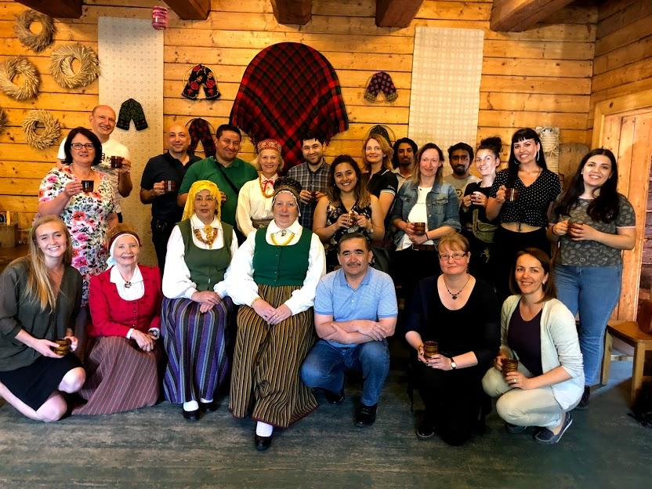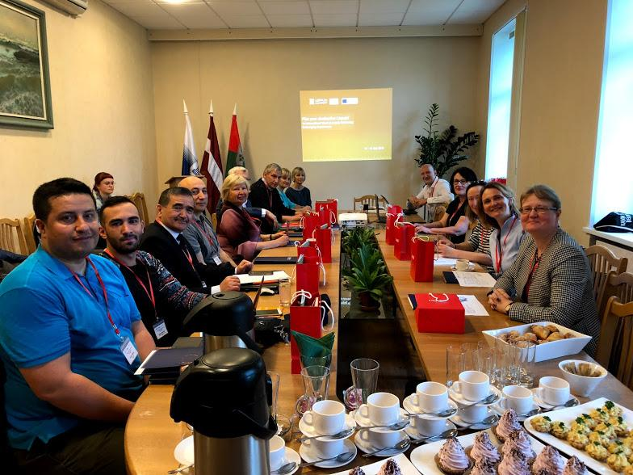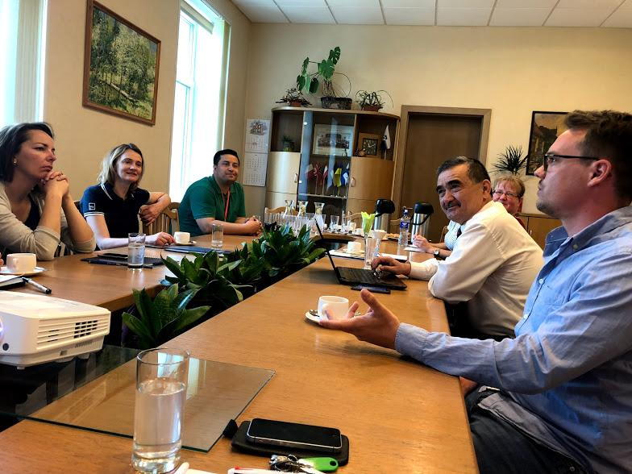
PARTICIPANTS OF THE INTERNATIONAL WEEK

